

Programme | : | M.Tech Int Software Engineering | Semester | : | Fall 2026-2027
Course | : | Database Systems Lab | Code | : | IASWE206
Faculty | : | Dr. M. Premalatha | Slot | : | L31+L32

Date: 12-10-2026
Ex No: 9
PL/SQL Procedures, Functions, Triggers and Cursors

Name:A Nathan Anthony
Reg no:25MIS1113

Ex:
SQL> create table student_mp(regno varchar(4), sname char(10), mobno number(10), dob date);
Table created.

SQL> desc student_mp
Name Null? Type
----------------------------------------- -------- ----------
REGNO VARCHAR2(4)
SNAME CHAR(10)
MOBNO NUMBER(10)
DOB DATE
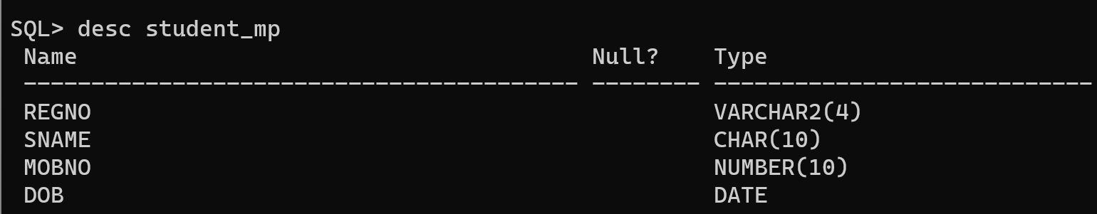

student(regno, sname, cgpa, school)
course(ccode, cname, credits)
faculty(empid, fname, designation, salary)
course_student(regno, ccode)
course_faculty(fid, ccode)

From the already created tables with key constraints of the above specified schema, write the SQL queries for the following:

- Add 0.5 cgpa to the student ‘ram’ [use procedure]
SQL Query:
SQL> CREATE OR REPLACE PROCEDURE add_cgpa AS
2 BEGIN
3 UPDATE student
4 SET cgpa = cgpa + 0.5
5 WHERE LOWER(sname) = 'ram';
6
7 IF SQL%ROWCOUNT > 0 THEN
8 DBMS_OUTPUT.PUT_LINE('CGPA updated successfully');
9 ELSE
10 DBMS_OUTPUT.PUT_LINE('Student ram not found');
11 END IF;
12 END;
13 /

Procedure created.

SQL>
SQL> EXEC add_cgpa;

PL/SQL procedure successfully completed.

SQL>
SQL> SELECT * FROM student WHERE LOWER(sname) = 'ram';

REGNO SNAME CGPA
---------- ------------------------------ ----------
SCHOOL
------------------------------
101 ram 7.7
SCOPE

Screenshot:
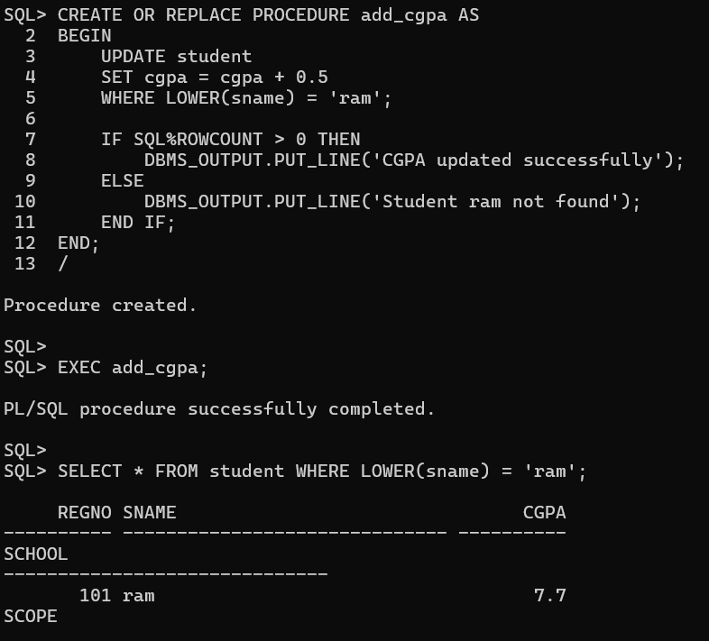
- Find the average salary of the ‘professors’ [use function]

SQL Query:
SQL> CREATE OR REPLACE FUNCTION avg_prof_salary
2 RETURN NUMBER
3 AS
4 v_avg NUMBER;
5 BEGIN
6 SELECT AVG(salary)
7 INTO v_avg
8 FROM faculty
9 WHERE UPPER(designation) = 'PROFESSOR';
10
11 RETURN v_avg;
12 END;
13 /

Function created.

SQL>
SQL> SELECT avg_prof_salary() AS average_salary
2 FROM dual;

AVERAGE_SALARY
--------------
71666.6667

Screenshot:
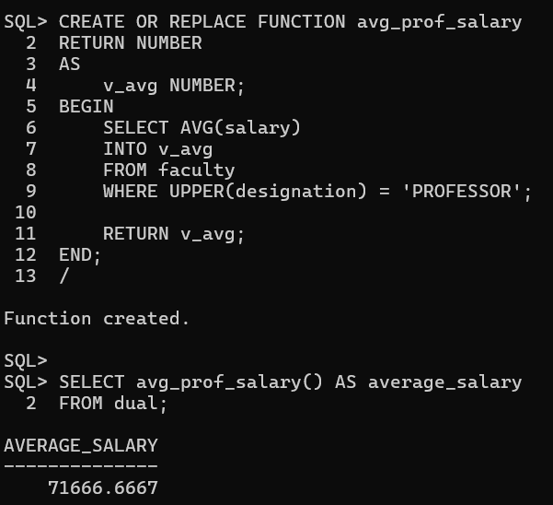
- List the course name registered by the student ‘lal’ [use implicit cursor]

SQL Query:
SQL> SET SERVEROUTPUT ON;
SQL> DECLARE
2 v_found NUMBER := 0;
3 BEGIN
4 FOR rec IN (
5 SELECT c.cname
6 FROM student s, course_student cs, course c
7 WHERE s.regno = cs.regno
8 AND cs.ccode = c.ccode
9 AND LOWER(s.sname) = 'lal'
10 )
11 LOOP
12 DBMS_OUTPUT.PUT_LINE('Course pursued: ' || rec.cname);
13 v_found := v_found + 1;
14 END LOOP;
15
16 IF v_found = 0 THEN
17 DBMS_OUTPUT.PUT_LINE('No courses found for Lal');
18 END IF;
19 END;
20 /
Course pursued: DBMS
Course pursued: Java Programming
Course pursued: Software Engineering

PL/SQL procedure successfully completed.

Screenshot:
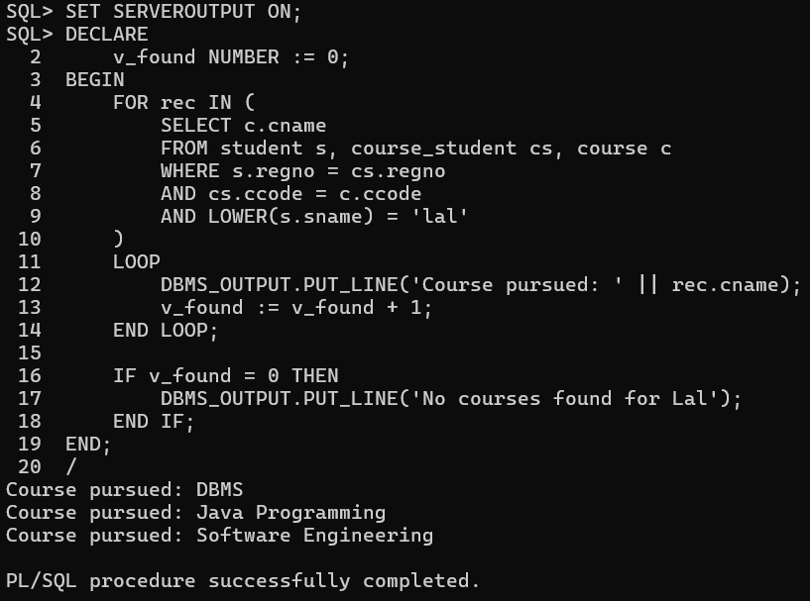
- List all the faculty names who receive salary more than the salary of ‘paul’ [use explicit cursor]

SQL Query:
SQL> SET SERVEROUTPUT ON;
SQL>
SQL> DECLARE
2 CURSOR c1 IS
3 SELECT fname
4 FROM faculty
5 WHERE salary > (
6 SELECT salary
7 FROM faculty
8 WHERE LOWER(fname) = 'paul'
9 );
10
11 v_name faculty.fname%TYPE;
12 v_count NUMBER := 0;
13
14 BEGIN
15 OPEN c1;
16
17 LOOP
18 FETCH c1 INTO v_name;
19 EXIT WHEN c1%NOTFOUND;
20
21 DBMS_OUTPUT.PUT_LINE(v_name);
22 v_count := v_count + 1;
23 END LOOP;
24
25 CLOSE c1;
26
27 IF v_count = 0 THEN
28 DBMS_OUTPUT.PUT_LINE('No faculty found');
29 END IF;
30 END;
31 /
David
Robert
Susan

PL/SQL procedure successfully completed.

Screenshot:
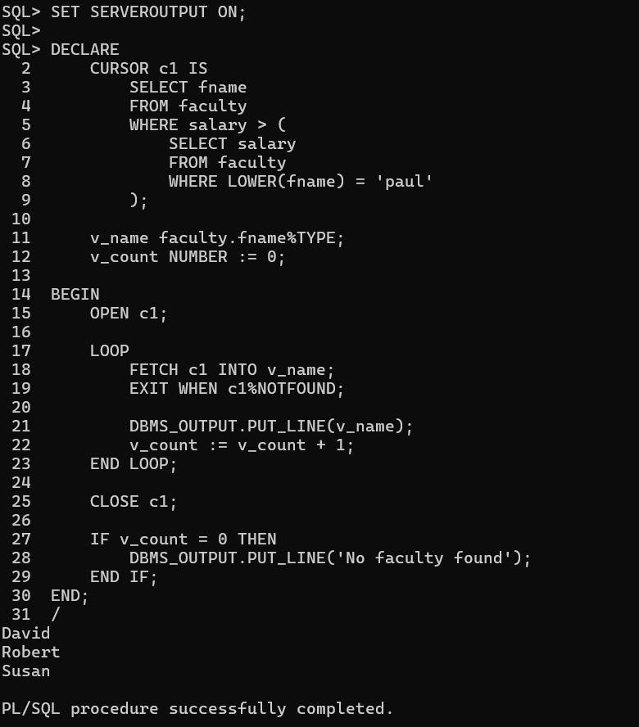
- Create a function to calculate the number of courses registered by a student.
SQL Query:
SQL> CREATE OR REPLACE FUNCTION count_courses(
2 p_regno NUMBER
3 )
4 RETURN NUMBER
5 AS
6 v_count NUMBER;
7 BEGIN
8 SELECT COUNT(*)
9 INTO v_count
10 FROM course_student
11 WHERE regno = p_regno;
12
13 RETURN v_count;
14 END;
15 /

Function created.

SQL>
SQL> SELECT s.regno, s.sname,
2 count_courses(s.regno) AS total_courses
3 FROM student s;

REGNO SNAME TOTAL_COURSES
---------- ------------------------------ -------------
101 ram 2
102 lal 3
103 john 1
104 mary 1
- arun 1

screenshot:
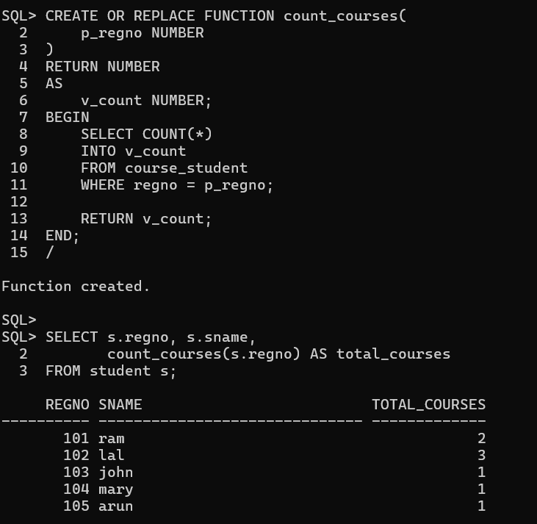
- Create a procedure to display faculty members teaching a particular course.

SQL Query:
SQL> SET SERVEROUTPUT ON;
SQL>
SQL> CREATE OR REPLACE PROCEDURE display_faculty(
2 p_ccode VARCHAR2
3 )
4 AS
5 v_count NUMBER := 0;
6 BEGIN
7 FOR rec IN (
8 SELECT f.fname
9 FROM faculty f
10 JOIN course_faculty cf ON f.empid = cf.fid
11 WHERE cf.ccode = p_ccode
12 )
13 LOOP
14 DBMS_OUTPUT.PUT_LINE('Faculty Name: ' || rec.fname);
15 v_count := v_count + 1;
16 END LOOP;
17
18 IF v_count = 0 THEN
19 DBMS_OUTPUT.PUT_LINE('No faculty found for this course');
20 END IF;
21 END;
22 /

Procedure created.

SQL> EXEC display_faculty('C101');
Faculty Name: paul
Faculty Name: Robert

PL/SQL procedure successfully completed.

SQL> EXEC display_faculty('C102');
Faculty Name: David

PL/SQL procedure successfully completed.

SQL> EXEC display_faculty('C103');
Faculty Name: Alice

PL/SQL procedure successfully completed.

SQL> EXEC display_faculty('C104');
Faculty Name: Susan

Screenshot:
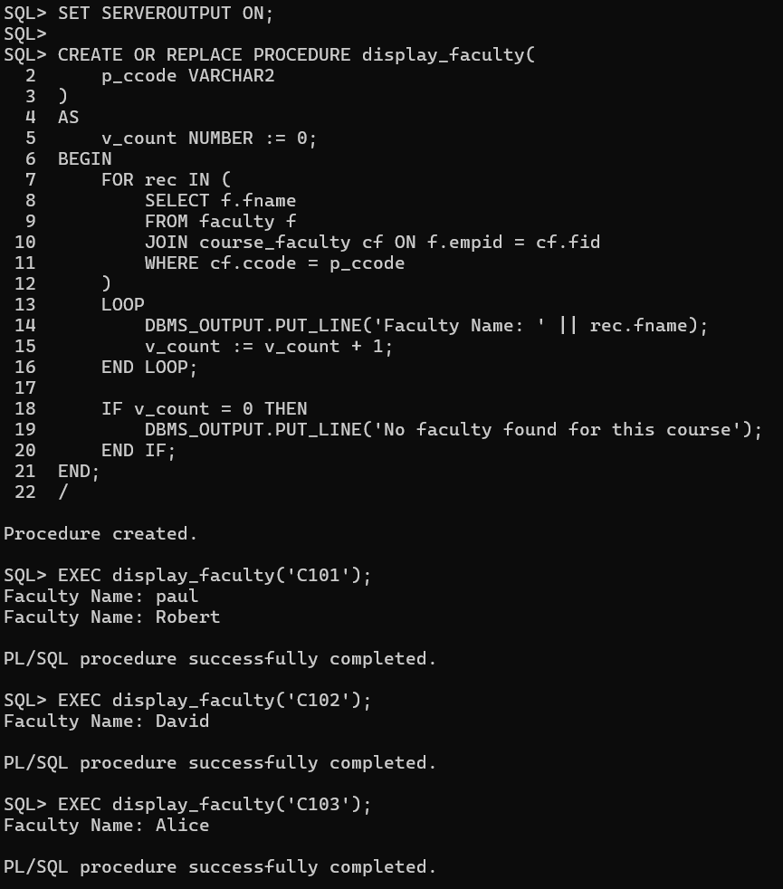
- Write a before update trigger on the student table to ensure that the CGPA entered is between 0 and 10.

SQL Query:
SQL> CREATE OR REPLACE TRIGGER check_cgpa
2 BEFORE UPDATE OF cgpa ON student
3 FOR EACH ROW
4 BEGIN
5 IF :NEW.cgpa < 0 OR :NEW.cgpa > 10 THEN
6 RAISE_APPLICATION_ERROR(
7 -20001,
8 'CGPA must be between 0 and 10'
9 );
10 END IF;
11 END;
12 /

Trigger created.

SQL> UPDATE student
2 SET cgpa = 8.5
3 WHERE regno = 102;

1 row updated.

SQL>
SQL> SELECT * FROM student WHERE regno = 102;

REGNO SNAME CGPA
---------- ------------------------------ ----------
SCHOOL
------------------------------
102 lal 8.5
SCOPE

SQL> UPDATE student
2 SET cgpa = 11
3 WHERE regno = 102;
SET cgpa = 11
*
ERROR at line 2:
ORA-01438: value larger than specified precision allowed for this column

Screenshot:
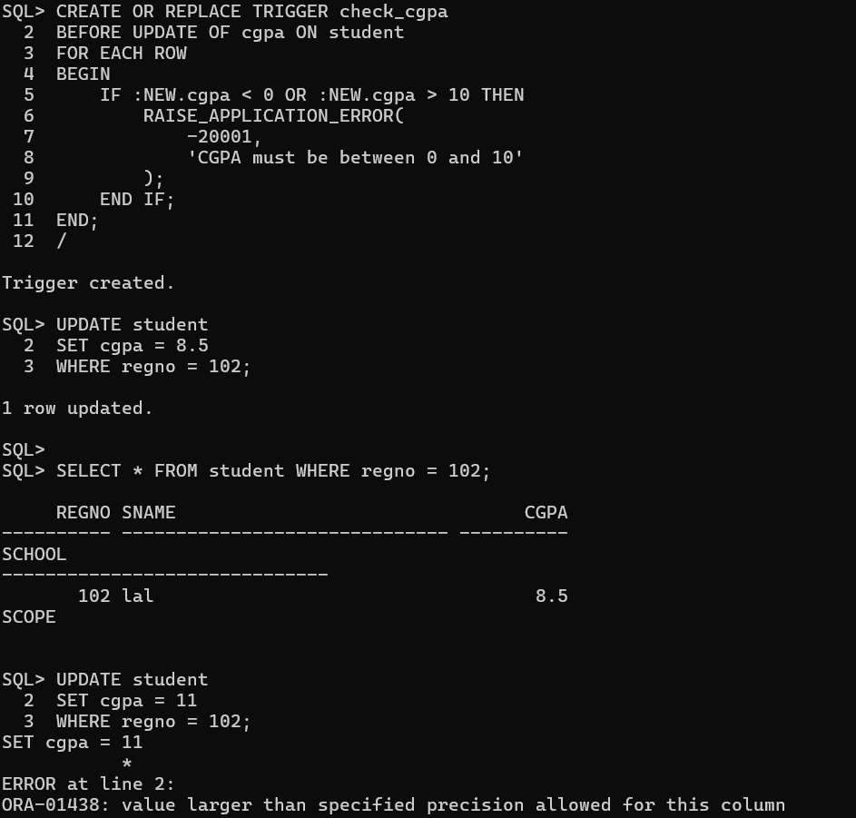
- Write a after update trigger on the faculty table to display the old and new salary whenever a faculty member's salary is updated.
SQL Query:

SQL> SET SERVEROUTPUT ON;
SQL>
SQL> CREATE OR REPLACE TRIGGER salary_update
2 AFTER UPDATE OF salary ON faculty
3 FOR EACH ROW
4 BEGIN
5 DBMS_OUTPUT.PUT_LINE('Faculty Name: ' || :NEW.fname);
6 DBMS_OUTPUT.PUT_LINE('Old Salary: ' || :OLD.salary);
7 DBMS_OUTPUT.PUT_LINE('New Salary: ' || :NEW.salary);
8 END;
9 /

Trigger created.

SQL> UPDATE faculty
2 SET salary = 65000
3 WHERE LOWER(fname) = 'paul';
Faculty Name: paul
Old Salary: 60000
New Salary: 65000

1 row updated.

Screenshot:
